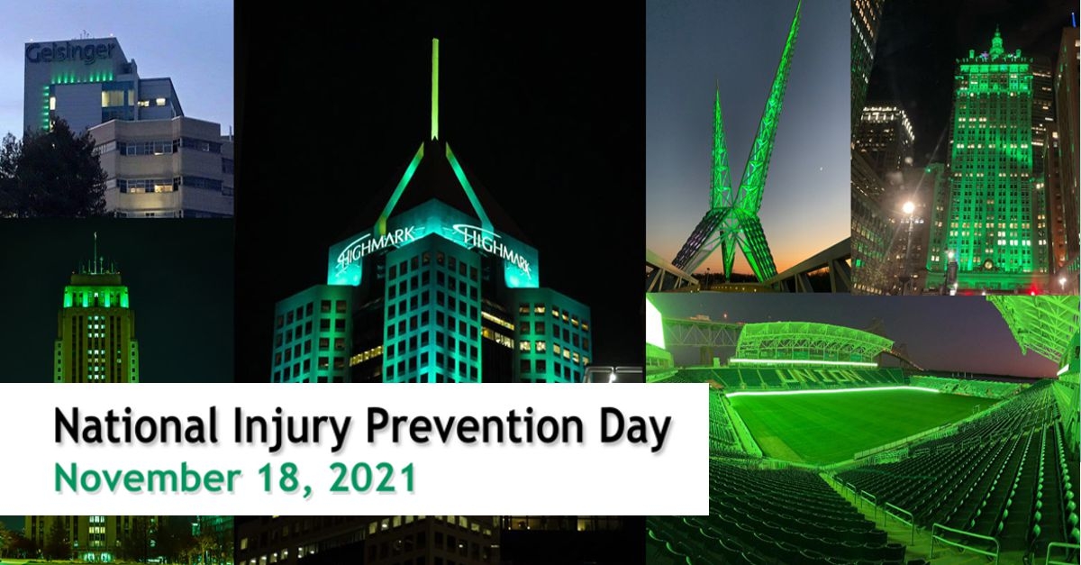
The Children’s Mercy Hospital is working with our community partners to address needless injuries and violence taking place in the greater Kansas City area. Did you know that every day 20 children needlessly die from preventable injuries – and their deaths make up more deaths than all other diseases combined? Their family members are also dying and being hospitalized.
Across the country, some of the nation’s leading injury and violence prevention organizations will come together to raise awareness about the burden of injury and violence. They will join forces to push for change on the 2nd annual "National Injury Prevention Day." Please Join us at Charlie’s House to reduce the risk of firearm injury to children in and around your home.
Charlie’s House
2425 Charlotte Street
Kansas City, MO 64108
9:00 – 9:30 a.m. COVID-19 Pre-screening of Participants
9:30 a.m. – 12:45 p.m. Charlie’s House Tour of Head Start Guest (reservation needed) – Tour reservations will be scheduled at 30 minute appointments. Click Here to reserve a time: https://www.charlieshouse.org/events-and-programs
Click on National Injury Prevention Community Day, on the Day (in bold on the calendar, Nov 18th) and select an available time slot.
Presenters
You may set up your station on Wednesday, November 17th, 3:00 to 5:00 p.m. Tables and chair(s) will be provided. Please advise Stuart Hoffman and/or Melissa Roach 816-591-1766 if you will require power for your station.
Please plan to arrive at Charlie’s House on Thursday, November 18th by 8:30 am to allow for pre-screening and setup prior to greeting our first guests. Street parking is available on Campbell and 24th Terrace. Please plan to arrive at Charlie’s House by 8:30 to allow for pre-screening and setup prior to greeting our first guests. We are requesting parking privileges in the UMKC parking lot – across the street for our guests. If you have questions/suggestions… please contact me – Phyllis Larimore (913) 314 5952 or plarimore@cmh.edu
Agenda
November 18, 2021
9:00 – 9:30 a.m. COVID-19 Pre-screening of all Participants
9:45 a.m. – 12:45 p.m. Charlie’s House Tour of Head Start Guest (reservation needed) – Tour reservations will be scheduled at 15 minute appointments
- Kansas City Mayor’s Proclamation for National Injury Prevention Day
- Missouri and Kansas Governor’s Proclamation for National Injury Prevention Day
- Pediatric Firearm Trauma in Greater KC Data – A Poster Presentation - Kristyn Jeffries M.D.
- Stop the Bleed - Jordan Palmer & Jessica Giacone (MTS)
- Mothers in Charge – Rosilyn Temple, Latrice Murray & Tammy Kemp
- BE SMART for Kids - Ann Stepp, Everytown for Gun Safety
- Lock It for Love – Barb McNeil Grandparents Against Gun Violence
- Firearm Safety Storage – Charmainne Sanders, Community Interaction Officer, Kansas City Police Department
- Be ready for a unexpected injury – guests may receive a first aid kit.
- Shining a Green Light on Injury Prevention - On Thursday, November 18th, 2021, as the sun goes down across the nation, and a day of community outreach comes to a close, city landmarks will take on a new look. Trauma Centers, businesses, bridges, government buildings and neighborhood homes will shine a green light. Guests will have an opportunity to receive a green light bulb to help shine a green light in their neighborhood!
NIPD Partners

Be SMART – Every Town for Gun Safety
Charlie's House
Children’s Mercy Hospital
City of Kansas City Missouri
Grandparents For Gun Safety
Johnson County KS Health Department
KCMO Health Department
KCMO Police Department
Lenita Johnson, IFCK
Mid America Head Start Association
Mid-West Trauma Society
Mothers in Charge
Nurture KC
Operation Breakthrough
Saint Luke’s Hospital
Samuel Rogers Health Center
Swope Health Services
YMCA of Greater Kansas City

